**Custom User with Token Authentication:**

Models.py:

Need to create UserManager:

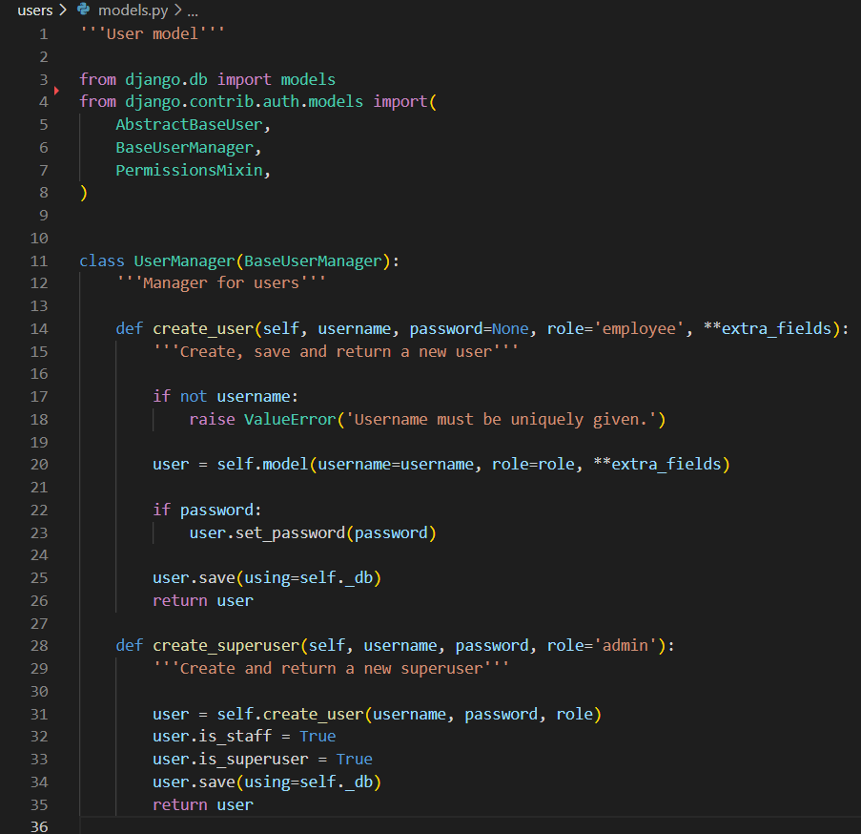

Now we can create the User Model:

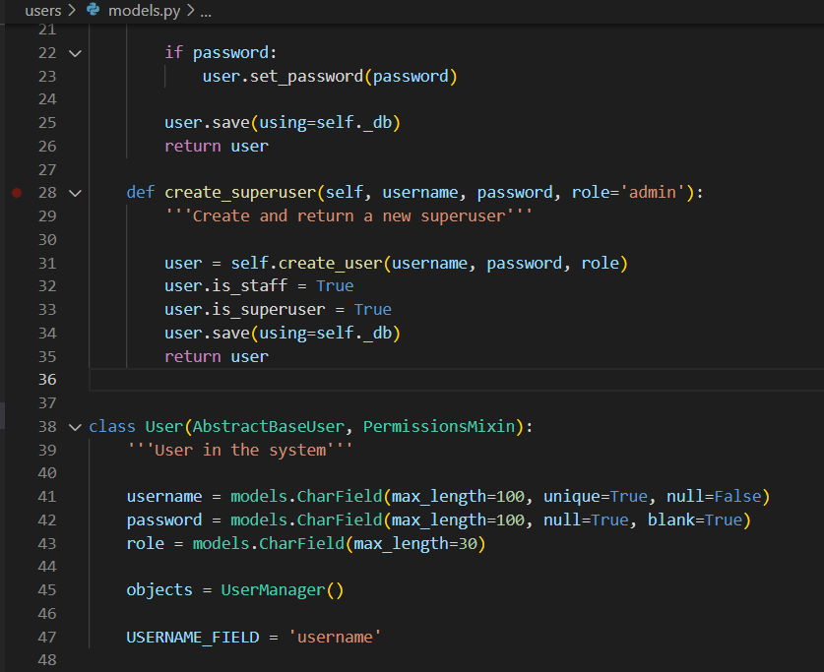

Serializers.py:

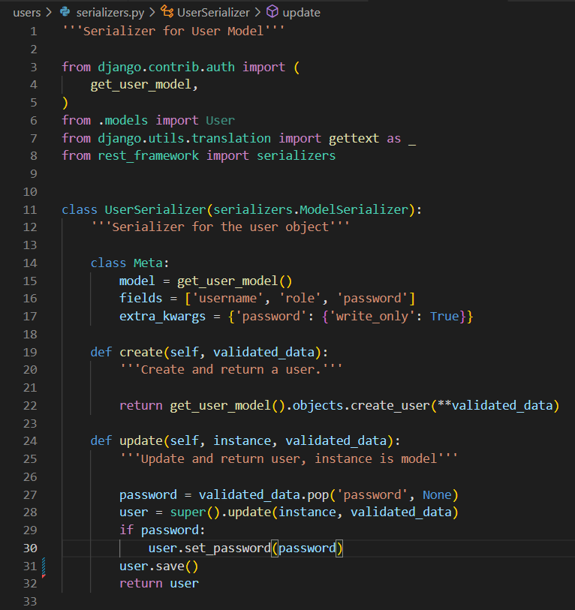

Views.py:

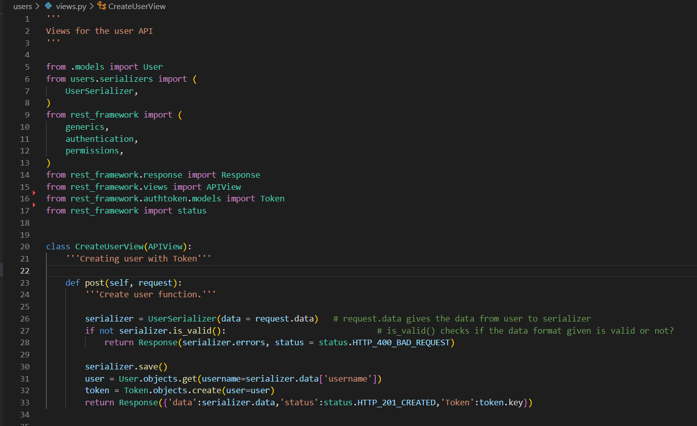

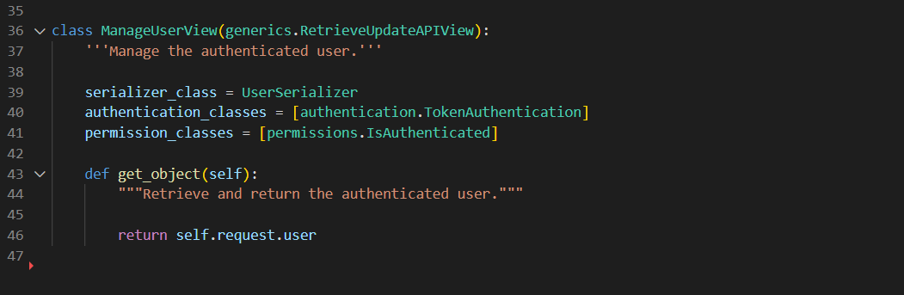

Urls.py:

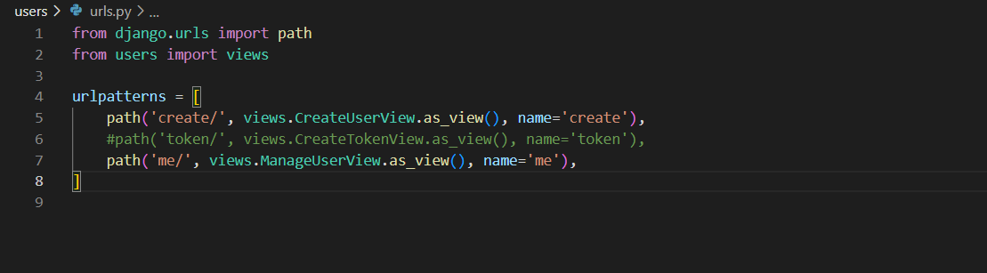

Apply Token Auth on Views and get Model Fields:

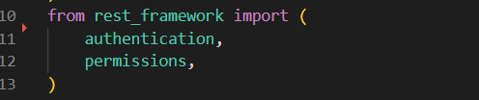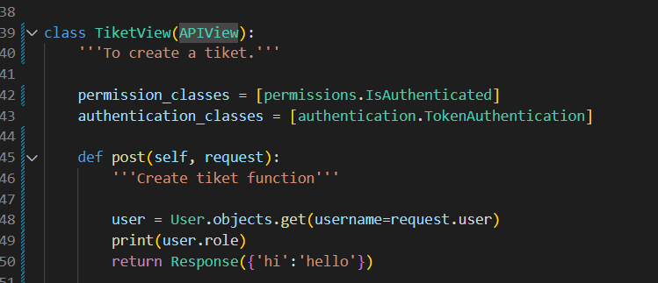

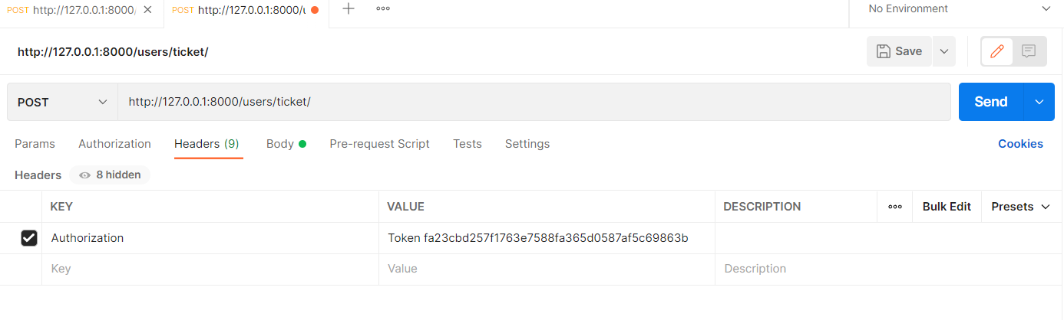

Create ticket Admin request:

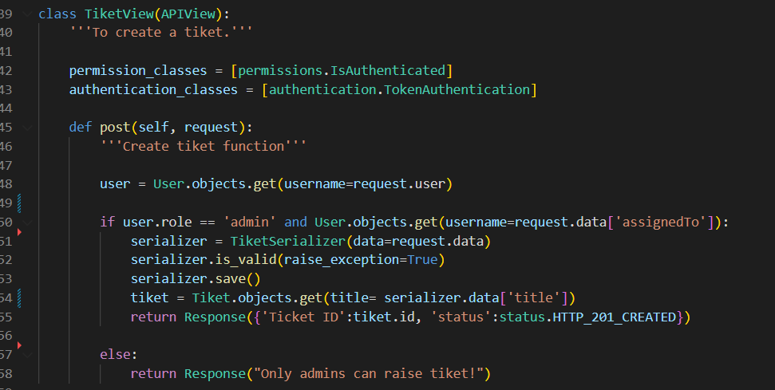

Get Ticket for existing user:

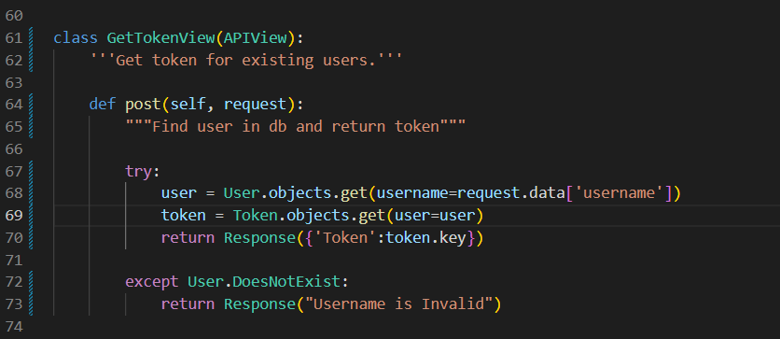

Get Value from URL:

